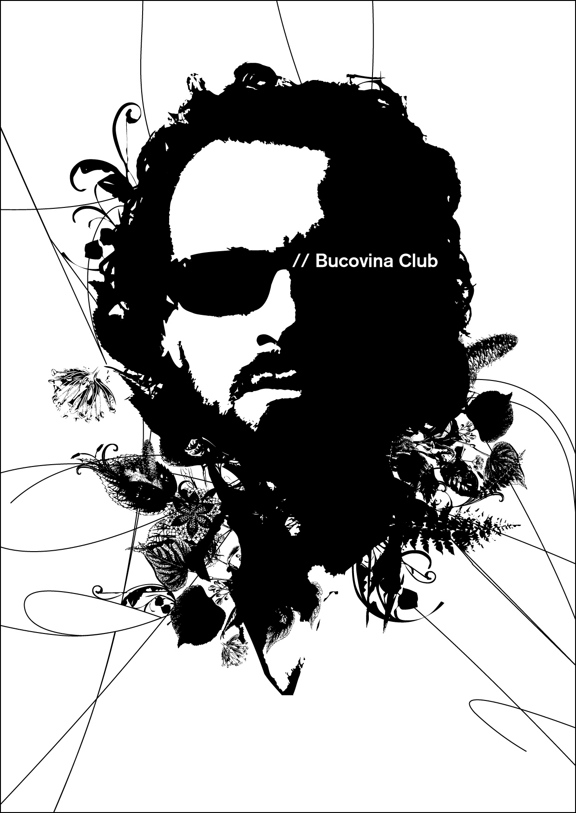


Liner notes for Shantel // Disko Partizani! album

Disko Partizani!

This album sets a milestone on the path of musician, producer and DJ Shantel. Who would have thought that this internationally-renowned producer of electronica would one day morph into the inventor of an avant-garde Balkan sound, moving into a completely new direction to rub shoulders with the very finest of southern Europe’s musical talent and embrace a wholly new musical vision? But what might seem, on the surface, to be a complete break, is in fact nothing less than the logical development of his musical experience as a child and adolescent. After the Second World War, Shantel’s mother and her family embarked upon a long and tortuous path to Germany from Bucovina – a formerly cosmopolitan region of the Habsburg Empire, now divided between Ukraine and Romania. The exotic sounds and voices of crackling old 78s and the lilt of the Romanian language his grandmother never abandoned were to lay the foundations for Shantel’s love affair with the music of eastern Europe’s urban ballrooms and concert halls, as well as its rural traditions – a musical heritage that spawned an astonishing meld of hybrid forms in the twentieth century. This much can be said: Shantel has never been one to pay much heed to any dogmatic insistence on musical “purity”. All these diverse sources of inspiration are what link the former electronica producer with the music of the Gypsies. Gypsy musicians form an intrinsic part of musical life in the Balkans. They are the true inventors of the art of sampling. In the course of their wanderings through many countries and cultures, they have always picked up a hookline here or a rhythm there, a fragment of melody or a refrain, only to put them together in some new and unheard constellation, creating something entirely their own. Towards the close of the twentieth century, sampling became the prevailing production method of a very different community: the electronica and hip hop scene.

Disko Partizani! reflects the search for a new musical language. This crazy cultural mix combines the best of two worlds, creating a brand-new fusion which blends centuries-old melodies and rhythms with the ideas and production methods of a contemporary musician. Disko Partizani! undermines the quest for musical "authenticity“ and runs against the grain of all conformist notions regarding style and form, to create instead an authenticity all its own. Central Europe has become the cradle of a musical phenomenon with global reach. The cultural influences of this innovative pop style are rooted in the countries that Shantel has travelled time and again, and in the places where he regularly works. He defines the sound of a new Europe, centered at the very heart of the old continent and blending the irresistible rhythms of the Balkans, Greece, Turkey and beyond. On this album, Shantel features as a singer and multi- instrumentalist, while at the same time showcasing some of southern Europe’s finest musical talents. It is precisely with this very blend of stylistic pyrotechnics (Balkan fire peppered with a pinch of electronic beats and sounds) that Shantel had already started revolutionizing the music scene with his now-classic Bucovina Club, shaking up a broad-based audience lulled into near-catatonia by the stultifying mediocrity of a homogenous club sound. No matter whether he performs as a musician and vocalist or as a DJ – wherever Shantel appears, he gets the dancefloor heaving with euphoric crowds of people who end up wondering, at the end of yet another spectacular night, what on earth it is they have just experienced. Crashing the stage, belly-dancing, stage-diving – everything can happen. In other words, thanks to Shantel, the Balkans have taken over the club scene. His work has inspired an entire generation of DJs to abandon house, techno and breakbeats in favour of this new sound. And yet, even as he transforms and fuses it to create new forms of urban music combining the very best of east and west in a newfound harmony, Shantel has never lost his deep sense of respect for the cultural roots of the music from which he draws. This creative approach has been recognized by such accolades as the BBC World Music Award.

All you have to do now is turn up the volume and dance. Or just shut your eyes and let your imagination take you to the places in which Shantel wrote this album: Romanian railway stations, Greek service stations, the departure hall of Istanbul airport, an Arab coffee shop in Tel Aviv, a taxi rank in Sofia, the back seat of a Macedonian Gypsy king’s Mercedes-Benz, the backstage of a club in London, Paris or Rio de Janeiro. Immerse yourself in the Babylonian confusion of languages which prevailed in the recording studio, and truly reflects the spirit of this album. After all, where else can you hear Greek and Turkish in one song, or English, Romanian and Serbian in a single recording?

Disko Partizani!

Jean Trouillet
Translated by Ishbel Flett

